**EXP: 8 Create an ARIMA model for time series forecasting**

**Aim:** To create an arima model for time series forecasting using autism screening dataset

**Procedure:**

**1.Import the necessary libraries:**

import pandas as pd

import matplotlib.pyplot as plt

from statsmodels.tsa.arima.model import ARIMA

from pandas.plotting import register_matplotlib_converters

register_matplotlib_converters()

**2. Load the dataset**

df = pd.read_csv("autism_screening.csv")

**3. Visualize the data**

monthly_positive.plot(title="Monthly Positive Autism Screenings")

plt.xlabel("Month")

plt.ylabel("Number of Positive Screenings")

plt.show()

**4. Check for stationarity (ADF test)**

from statsmodels.tsa.stattools import adfuller

result = adfuller(monthly_positive.dropna())

print(f"ADF Statistic: {result[0]}")

print(f"p-value: {result[1]}")

**5. Fit ARIMA model and Print the summary of the model**

model = ARIMA(monthly_positive, order=(1, 1, 1)) # ARIMA(p,d,q)

model_fit = model.fit()

print(model_fit.summary())

**6. Visualize the forecast**

monthly_positive.plot(label='Actual', color='blue')

forecast_series.plot(label='Forecast', color='red', linestyle='--')

plt.title("Forecast of Positive Screenings for Autism")

plt.xlabel("Date")

plt.ylabel("Number of Positive Screenings")

plt.legend()

plt.show()

**OUTPUT:**

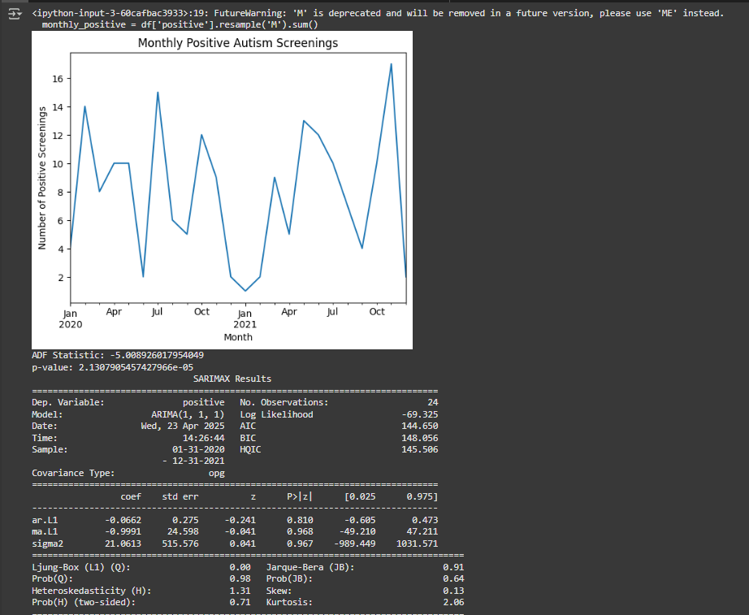

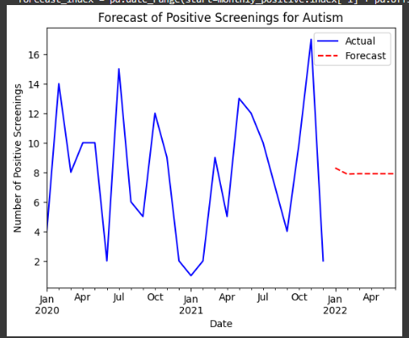

**Result:** This program to develop an arima model for time series forecasting using autism screening dataset implemented and executed successfully

